Project Design Phase-II
Data Flow Diagram & User Stories

Date | 13 June 2026 | Team ID | N/A (Solo Project)
Project Name | Network Anomaly Detection | Maximum Marks | 4 Marks

Data Flow Diagrams:
A Data Flow Diagram (DFD) is a traditional visual representation of the information flows within a system. A neat and clear DFD can depict the right amount of the system requirement graphically. It shows how data enters and leaves the system, what changes the information, and where data is stored.

DFD Level 1 — Network Anomaly Detection System
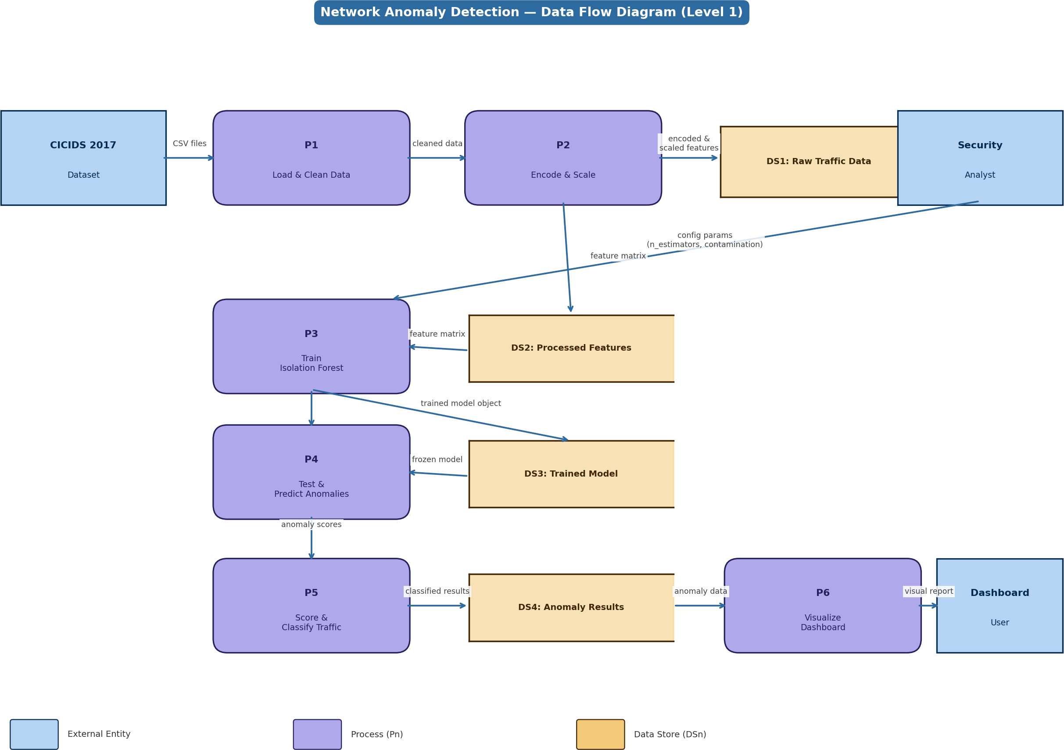

Figure 1: Level 1 DFD showing data flow from CICIDS 2017 dataset through preprocessing, model training, anomaly scoring, and visualization dashboard

DFD Elements & Descriptions

Element | ID | Name | Description
External Entity | EE1 | CICIDS 2017 Dataset | Source of raw network traffic data in CSV format with 80+ features
External Entity | EE2 | Security Analyst | Configures model parameters (n_estimators, contamination threshold)
External Entity | EE3 | Dashboard User | End user who views the anomaly visualization dashboard
Process | P1 | Load & Clean Data | Reads CSV files, removes nulls, duplicates and irrelevant columns

Process | P2 | Encode & Scale Features | Converts text columns to numbers (LabelEncoder) and normalises ranges (StandardScaler)
Process | P3 | Train Isolation Forest | Builds 100 isolation trees on processed training data using sklearn
Process | P4 | Test & Predict Anomalies | Passes unseen traffic through the frozen trained model to get predictions
Process | P5 | Score & Classify Traffic | Applies contamination threshold to anomaly scores; classifies each flow as Normal or Anomaly
Process | P6 | Visualize Dashboard | Plots flagged anomalous traffic using Matplotlib/Plotly for analyst review
Data Store | DS1 | Raw Traffic Data | Stores the original loaded network traffic features before processing
Data Store | DS2 | Processed Features | Stores encoded and scaled feature matrix ready for model input
Data Store | DS3 | Trained Model | Stores the serialised Isolation Forest model object (.pkl file)
Data Store | DS4 | Anomaly Results | Stores classification output — anomaly scores and Normal/Anomaly labels per flow

User Stories
Use the below template to list all the user stories for the product.

User Type | Functional Requiremen t (Epic) | Story No. | User Story / Task | Acceptance Criteria | Priority | Release
Security Analyst | Data Ingestion | USN-1 | As a security analyst, I can load the CICIDS 2017 dataset CSV files into the system. | Data loads without errors; row count matches source file | High | Sprint-1
 | Data Ingestion | USN-2 | As a security analyst, I can view a summary of loaded data (rows, columns, null counts). | Summary statistics are displayed correctly | Medium | Sprint-1
 | Pre-processing | USN-3 | As a security analyst, I can trigger data cleaning to remove nulls and duplicates. | Dataset has zero null values and no duplicate rows after cleaning | High | Sprint-1
 | Pre-processing | USN-4 | As a security analyst, I can encode and scale features before model training. | All features are numeric and normalised to equal ranges | High | Sprint-1
 | Model Training | USN-5 | As a security analyst, I can configure model parameters (n_estimators, contamination) before training. | Model trains with specified parameters without errors | High | Sprint-1
 | Model Training | USN-6 | As a security analyst, I can train the Isolation Forest model on the processed dataset. | Model trains successfully and is saved as a .pkl file | High | Sprint-1
 | Detection | USN-7 | As a security analyst, I can run anomaly detection on unseen network traffic. | Each traffic flow receives an anomaly score between 0 and 1 | High | Sprint-2
 | Detection | USN-8 | As a security analyst, I can view which traffic flows are classified as anomalies vs normal. | Output clearly labels each flow as Normal or Anomaly | High | Sprint-2
Dashboard User | Visualization | USN-9 | As a dashboard user, I can view a chart of anomaly scores across all traffic flows. | Score distribution plot renders correctly with flagged flows highlighted | High | Sprint-2
 | Visualization | USN-10 | As a dashboard user, I can see which features contributed most to flagged anomalies. | Top contributing features are listed or visualised per anomaly | Medium | Sprint-3
 | Reporting | USN-11 | As a dashboard user, I can export anomaly detection results to a CSV file. | Exported CSV contains flow ID, score, and Normal/Anomaly label | Medium | Sprint-3

User Type | Functional Requiremen t (Epic) | Story No. | User Story / Task | Acceptance Criteria | Priority | Release
System | Performance | USN-12 | As a system, I can evaluate model performance using precision, recall, and F1-score. | Evaluation metrics are computed and displayed after each test run | High | Sprint-2

Project: Network Anomaly Detection | Phase: Project Design Phase-II | Solo Developer

